  - Scripting Task

- Create a shell script to print the HTTP error code of guvi.in & print, the success/failure message based on the error code response.

#!/bin/bash
url="https://www.guvi.in/"
status=$(curl -o /dev/null -s -w "%{http_code}" "$url")
echo "Checking $url"
echo "HTTP Status Code: $status"
if [ "$status" -eq 200 ]; then
echo "success"
else
echo "failure"
fi

output:
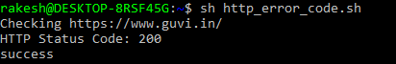

- Given a file, replace all occurrence of the word "give" with "learning" from 5th line till the end in only those lines that contain the word "welcome"

Given sample file name: example_file.txt
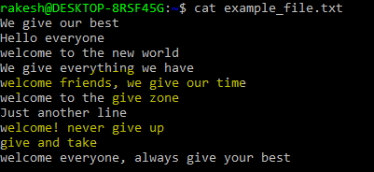
sed -i '5,${/welcome/s/give/learning/g}' example_file.txt

It will start replacing from line 5 till the end($). If the line contain “welcome” then it replace all “give” with “learning” in the example_file.txt

